Task 4 – Predictive Modelling Using Neural Networks

Task 4.1 – Processing the Dataset for Neural Network Modelling
Most data cleaning such as handling missing values, dropping non-predictive variables, and one-hot encoding categorical features—was completed in Tasks 1 to 3. The same training and test splits were retained to maintain a consistent baseline.
Additional preprocessing was required specifically for neural network training:
StandardScaler: Neural networks are sensitive to the differences in the scale of input variables. The scaler was fitted using fit_transform()
# Standadise the predictor variables. #
scaler = StandardScaler()
X_train_scaled = scaler.fit_transform(X_train)
X_test_scaled = scaler.transform(X_test)
Leakage Prevention: The scaler was fitted strictly on X_train using fit_transform() and then applied to X_test using transform(). Fitting across the entire dataset prior to splitting would constitute data leakage by exposing test distribution parameters ($μ,σ$) to the training pipeline.

Task 4.2 – Neural Network Model Using All Predictor Variables
An initial multi-layer perceptron (MLPClassifier) was constructed using all 120 predictor variables. 10-fold cross-validation with GridSearchCV optimized for ROC-AUC rather than raw accuracy.
# Task 4.2 - Neural Network - All Predictor Variables. #
# Create neural network model.
nn_full = MLPClassifier(
random_state=42,
max_iter=500
)
Class Imbalance: Roughly 87% of observations belong to the majority class (IsBadBuy = 0). A naive model predicting all zeros hits 87% accuracy while being commercially useless. ROC-AUC evaluates ranking discrimination across all classification thresholds regardless of base rates.
# Prepare the grid search with cross validation. #
grid_full = GridSearchCV(
estimator=nn_full,
param_grid=param_grid_full,
cv=10,
scoring='roc_auc',
n_jobs=-1
)

Task 4.2(A) – Parameters and Hyperparameter Search
Base Settings: max_iter = 500; and
random_state = 42.
Tuning Grid:
Hyperparameter | Values Tested
hidden_layer_sizes | (50,),  (100,),  (50, 25),  (100, 50)
activation | ['relu', 'tanh'],
alpha | [0.0001, 0.001, 0.01],
learning_rate_init | [0.001, 0.01]
Best parameters for NN1:
- Best parameters:
- {'activation': 'relu', 'alpha': 0.01, 'hidden_layer_sizes': (100,), 'learning_rate_init': 0.01}
- Best cross-validation ROC-AUC: 0.7103

Task 4.2(B) – Classification Accuracy
- Training accuracy: 0.9076
- Test accuracy: 0.8879
There was a gap of 1.97 % between training and testing datasets. Given the ~87% majority in not IsBadBuy, these figures mask the model's ability to discriminate classes, reinforcing the necessity of ROC-AUC.

Task 4.2(C) – Convergence
- Iterations: 96
- Final loss: 0.2796941603034794
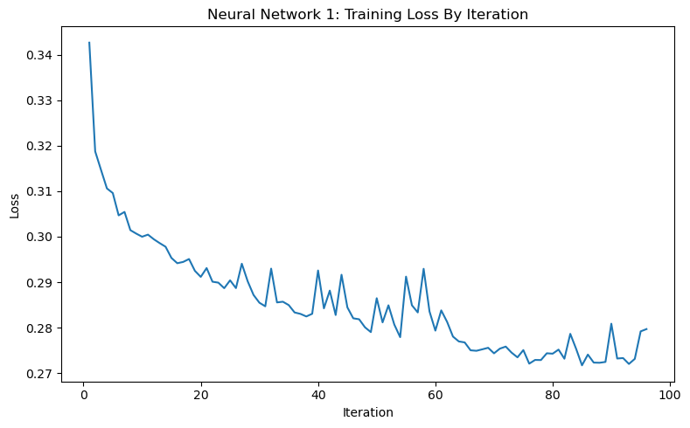
The training loss curve flattened steadily, and the optimiser triggered early stopping because the rate of error improvement was too low rather than hitting the 500-iteration ceiling. The model converged cleanly.

Task 4.2(D) – Overfitting
Assessment: Mild overfitting is present.
Evidence: The 1.97% drop in test accuracy combined with a modest test ROC-AUC (0.7266). The test performance degraded slightly (2 %) which suggestes this mostly influenced by the 87 % imbalance for not IsBadBuy and reinforces the need for the AUC.
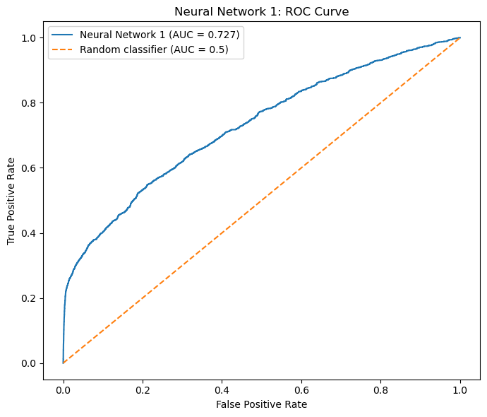

Task 4.3 – Neural Network Model Using the Reduced Feature Set
A reduction of features was conducted using the top 5 features identified by Task 2’s decision tree feature importance:
# Features selected using Decision tree feature importance. #
selected_features = [
'WheelType_UNKNOWN',
'VehYear',
'Auction_MANHEIM',
'VehBCost',
'MMRAcquisitionAuctionAveragePrice'
]

# Create reduced training and test datasets. #
X_train_reduced = X_train[selected_features].copy()
X_test_reduced = X_test[selected_features].copy()

# Check dimensions of reduced datasets. #
print("Reduced training data:", X_train_reduced.shape)
print("Reduced test data:", X_test_reduced.shape)

X_train_reduced.head()
- WheelType_UNKNOWN
- VehYear
- Auction_MANHEIM
- VehBCost
- MMRAcquisitionAuctionAveragePrice
Features were reduced by ~95.8% (from 120 to 5).
A separate StandardScaler was fit to the 5-feature training set and transformed onto the test set.
# Standardise the reduced predictor variables. #
scaler_reduced = StandardScaler()
X_train_reduced_scaled = scaler_reduced.fit_transform(
X_train_reduced
)

X_test_reduced_scaled = scaler_reduced.transform(
X_test_reduced
)

# Check dimensions #
print("Scaled reduced training data:", X_train_reduced_scaled.shape)
print("Scaled reduced test data:", X_test_reduced_scaled.shape)

The identical 10-fold CV GridSearchCV space was evaluated on NN2.
grid_reduced = GridSearchCV(
estimator=nn_reduced,
param_grid=param_grid_reduced,
cv=10,
scoring='roc_auc',
n_jobs=-1
)

Task 4.3(A) – Feature Selection & Architecture Changes
Outcome: Feature selection strongly favoured the model. By reducing the features from 120 to 5 much of the noise within the dataset was trimmed. The 120 inputs had to apply an aggressive learning rate of 0.01 because of the rough optimisation surface. Having to deal with only 5 features smoothed out the optimisation surface and allowed a more precise learning rate of 0.001.
NN1 vs NN2 Architectural Comparison:
Metric / Setting | NN1 (All 120 Features) | NN2 (Reduced 5 Features)
Input Features | 120 | 5
Hidden Layer Shape | (100,) | (50,)
Activation | relu | tanh
Alpha (L2 Penalty) | 0.01 | 0.001
Initial Learning Rate | 0.01 | 0.001
CV ROC-AUC | 0.7103 | 0.7517

Trimming 115 noisy inputs allowed a 50% smaller hidden layer to extract stronger predictive signals, increasing the cross-validated ROC-AUC from 0.7103 to 0.7517.

Task 4.3(B) – Classification Accuracy Comparison
- NN1 (Full):
  - Training accuracy: 0.9076
  - Test accuracy: 0.8879
  - Gap: 1.97 %
- NN2 (Reduced):
  - Training accuracy: 0.8978
  - Test accuracy: 0.8958
  - Gap: 0.20 %
Training accuracy fell slightly (-0.98 %), but test accuracy rose (+0.79 %). Sacrificing in-sample features directly boosted test samples accuracy.

Task 4.3(C) – Number of Training Iterations
- NN1
  - Iterations: 96
  - Final loss: 0.2796941603034794
- NN2:
  - Iterations: 39
  - Final loss: 0.3114856888441988
- Convergence: Full convergence achieved at iteration 39 which is well before the 500 limit.

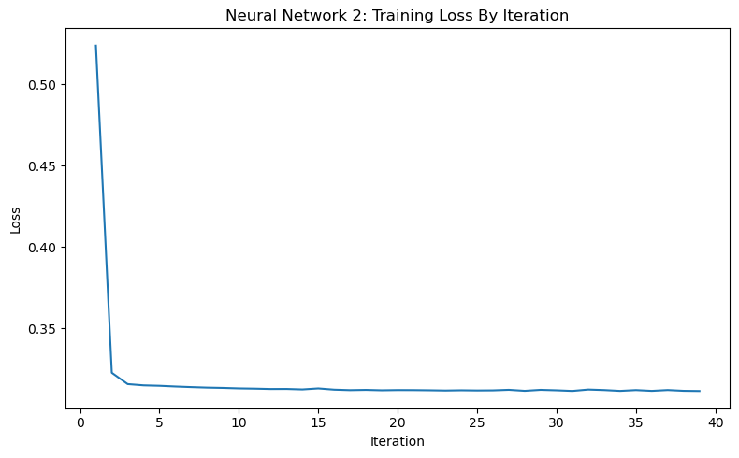A 59 % reduction in required iterations. Fewer features lead to a smoother surface that allowed the loss landscape to be navigated much faster. The higher final loss in NN2 is standard regularised behaviour: it avoided fitting noise (bumps) and yielded superior test metrics.

Task 4.3(D) – Overfitting
Overfitting: Virtually eliminated. The test-to-train gap narrowed to 0.20 pp.
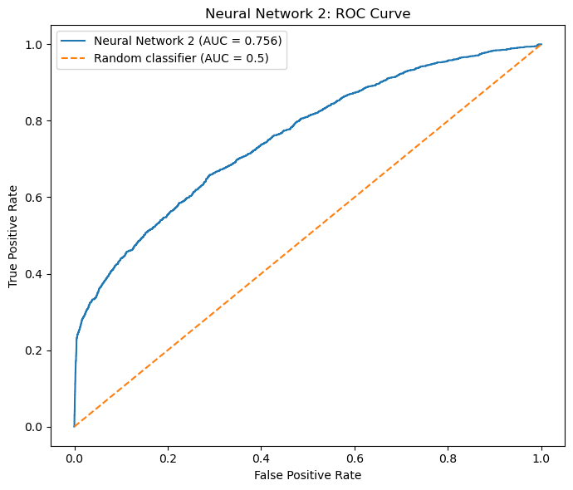

Task 4.4 – ROC Curve Comparison and Characteristics of Kicks
Performance Summary:
Model | Inputs | Train Acc. | Test Acc. | Test ROC-AUC
NN1 (Full) | 120 | 90.76% | 88.79% | 0.7266
NN2 (Reduced) | 5 | 89.78% | 89.58% | 0.7563

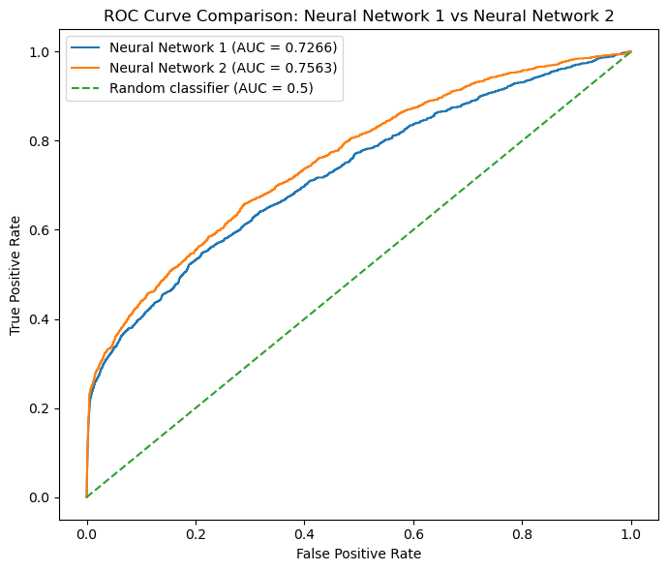
NN2 is better NN1 across the following metrics: higher test accuracy (+0.79 %), higher test ROC-AUC (+0.0297), negligible overfitting gap and faster training.

Characteristics of Kicks & Interpretability Limitations
Extracting direct kick characteristics from NN2 illustrates a classic "black-box" trade-off:
- Non-Linear Entanglement:
  - Unlike logistic regression (which gives linear log-odds coefficients) or decision trees (which provide explicit if-then split paths), a neural network processes inputs through hidden layer transformations ($tanh$) and dense weight matrices.
- Feature Interactions:
  - The impact of VehBCost or VehYear variables on kick probability is volatile because the direction can go either way and are heavily dependent on the simultaneous states of the other inputs.
- Derived Context from Feature Selection:
  - While NN2 confirms that WheelType_UNKNOWN, VehYear, Auction_MANHEIM, VehBCost, and MMRAcquisitionAuctionAveragePrice drive kick risk, we rely on the upstream Task 2 tree to establish directionality (e.g., vehicles with missing/unknown wheel records, older models, and anomalies between purchase cost and market average price carry substantially higher lemon risk).

Overall Task 4 Conclusion
Dropping 115 variables improved test ROC-AUC from 0.7266 to 0.7563 while slashing convergence time by about 59 %. Neural networks on tabular data can be susceptible to noise therefore excluding uninformative one-hot features allowed NN2 to reach parity with Task 3's reduced logistic regression (~0.763), providing a solid foundation for the final Task 5 multi-model comparison.

